Template for paper

Paper Title (12 point, Times New Romance, normal style)

Author Name¹, Author Name², Author Name^{3*}

¹Department of ---------------------------, University Name, City, Country

²Department of ---------------------------, University Name, City, Country

³Department of ---------------------------, University Name, City, Country
Email:

Abstract
150 to 250 words (11 point, Times New Romance, normal style).

Keywords: 3 – 5 words, in alphabetical order (11 point, Times New Romance, italics)
- TITLE (11 point, bold, capitalization, number “1.”, “2.”).
- Use a normal font (11 point Times New Roman) for text.
- Use tab stops or other commands for indents, not the space bar.
- Save your file in docx format (Word 2017 or higher).
1.1 Title (11 point, bold)
1.1.1 Title (11 point, bold)
1.1.2 Equation
- Use the equation editor or MathType for equations (11 point, Times New Romance, normal style).
1.2 Figure
- The image is a high-contrast black-and-white image (dpi ≥ 300).
- Figure captions begin with the term Fig. in bold type, followed by the figure number, also in bold type.
1.3 Table
- All tables are to be numbered using Arabic numerals.
- Use the table function, not spreadsheets, to make tables.
- Tables should always be cited in text in consecutive numerical order.
- For each table, please supply a table caption (title) explaining the components of the table.

References
- APA Style
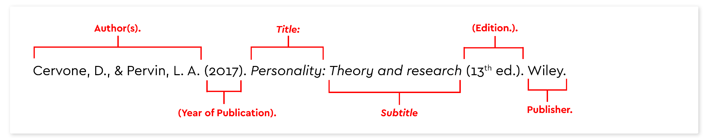
The paper should has maximum 25 pages (Including appendices)

